5种模型

1. single stage

2. two stage

3. three stage

4. h model 要背

5.

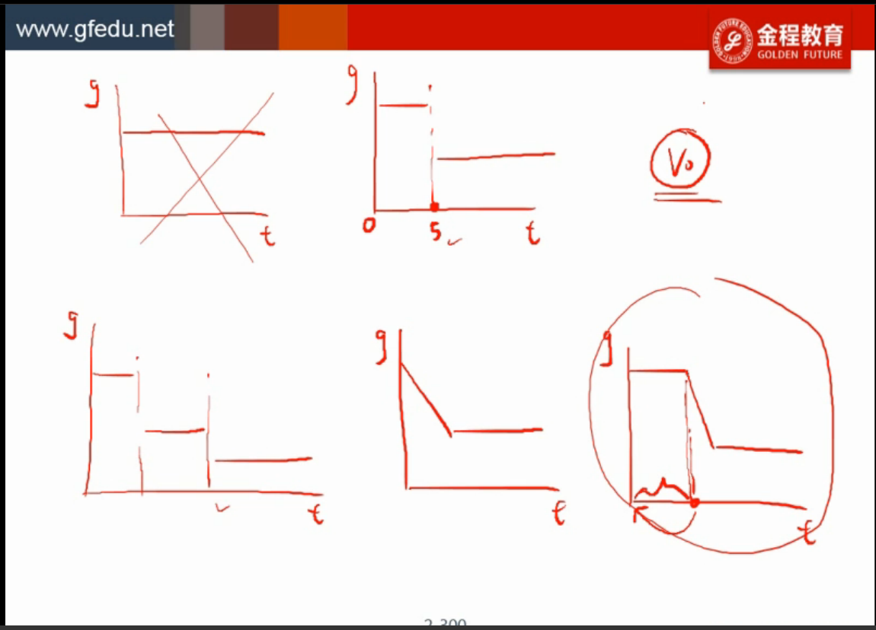

算terminal value

1. 用GGM算

TV5 = D5\*(1+g)/(r-g)

2. 用P/E算

TV5 = EPS5 \* P/E5

EPS5 = D5 / divdend payout ratio

区分给的是 trailing pe 还是 leading pe

给了trailing pe :

p0 = d0(1+g)/(r-g)

trailing pe

= p0/e0

= p0/(d0/(1-b))

= d0(1+g)/(r-g)/d0 \* (1-b)

= (1+g)\*(1-b)/(r-g)

b: retension ratio

TV5 = EPS5 \* trailing P/E5

给了leading p/e :

leading pe

= p0/e1

TV5 = EPS6 \* trailing P/E5